Practicum Case | 
COMP6826
Deep Learning
Computer Science | E241-COMP6826-NJ01-03
Valid on Even Semester Year 2023/2024 | Revision 00

Learning Outcomes
- Explain the fundamental deep learning theory
- Construct deep learning codes
- Analyze theoretical deep learning models
- Execute proper deep learning experimentation workflows

Topic
- Convolutional Neural Network

Subtopics
- Deep Convolutional Neural Network
- Example of DCNN Architecture

Soal
Case

Multi Class Rice Classification using
Convolutional Neural Network

In the domain of precision agriculture, accurately classifying rice varieties is crucial for tasks like yield estimation and targeted resources allocation. Convolutional Neural Networks (CNNs) offer a powerful approach to achieving this goal. Unlike traditional machine learning methods, CNNs excel at extracting features directly from image data. This capability makes them particularly well-suited for analyzing rice grain images, where subtle variations in shape, color, and texture can differentiate between varieties.

A CNN typically comprises multiple convolutional layers followed by pooling layers and fully connected layers. Convolutional layers apply filters that learn to detect specific patterns within the image. Pooling layers then downsample the data, reducing its dimensionality while preserving essential features. Finally, fully connected layers integrate the extracted features to arrive at a classification output. Through this process, the CNN model progressively learns to identify the characteristics that distinguish various rice varieties within the input images. This data-driven approach allows CNN to capture the complex relationships between visual features to corresponding rice classes, achieving high classification accuracy.

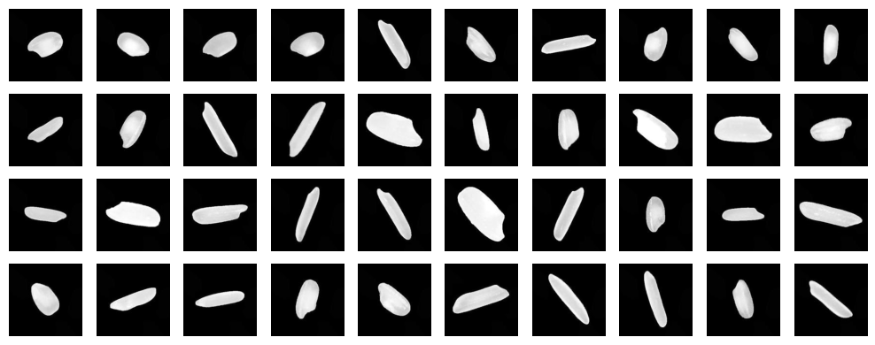
Figure 1. Rice Classification Dataset

The following is the step-by-step guide to create the CNN Model:
- Data Loading
  - Loading the Data & Data Preprocessing
    - The first step is loading images from the dataset folder. Since rice classification focuses heavily on analyzing texture and shape, rather than color variations, all images must be converted to grayscale format. This is because the rice color tends to be consistent across different varieties of rice, as most rice grains are white. Converting to grayscale allows the model to concentrate on the more informative features like texture and shape for accurate classification.
    - Append each image and class to their respective list.
- Explanatory Data Analysis (Optional)
  - Image count for each class
    - Print count of image that are collected for each class. Make sure they are all similar.
  - Image shape
    - Print the shape of the image from a sample, reshape the images to uniform size if they are not equal.
  - Image Example
    - Create plotting to show the loaded image with their labels.
- Data Preprocessing
  - Define Hyperparameters
    - Define hyperparameters that will be used for the model.
  - One Hot Encoding
    - Convert the number class list to categorical because each target variable represents distinct categories, and the order doesn’t hold any inherent meaning.
- Data Splitting
  - Train-Test-Val Split
    - Split the dataset into training, testing, and validation sets with a ratio of 80% for training, 10% for validation, and 10% for testing.
- Model Creation
  - Deep Convolutional Neural Network Initialization
    - Initialize the Neural Network with multiple Convolutional 2D layer with multiple units. Make sure the input shape for the first layer is equal to the image shape.
    - Pooling layers are inserted periodically between convolutional layers to downsample the data, reducing its dimensionality while preserving the essential features extracted by the preceding Convolutional Layers
    - Flatten layers are inserted after the convolutional and pooling layers to transform the extracted features from a multi-dimensional array into a one-dimensional vector.
    - Insert multiple dense layers with activation functions. These layers perform matrix multiplications to learn non-linear relationships between the features. Activation functions are applied after each dense layer to introduce non-linearity into the model, allowing it to capture more intricate patterns in the data.
    - The final dense layer uses a softmax activation function. It transforms the output values of the last layer into probabilities. The number of units in this layer should match the total number of target classes (different rice varieties).
  - Compile Model
    - Compile the model using Adam Optimizer, Categorical Cross Entropy to calculate the loss, and Accuracy as the metric.
- Model Training
  - DCNN Model Training
    - Train the DCNN Model using the training input and training output. The training process involves multiple epochs and provides the validation data to be a tuple of the validation input and validation output. Input the batch size so the model will learn the dataset by batches, not all at once.
- Model Evaluation and Testing
  - Prediction of Test Data
    - Predict the price of the testing input using the trained model. Compare the model prediction with the actual price from the test output.
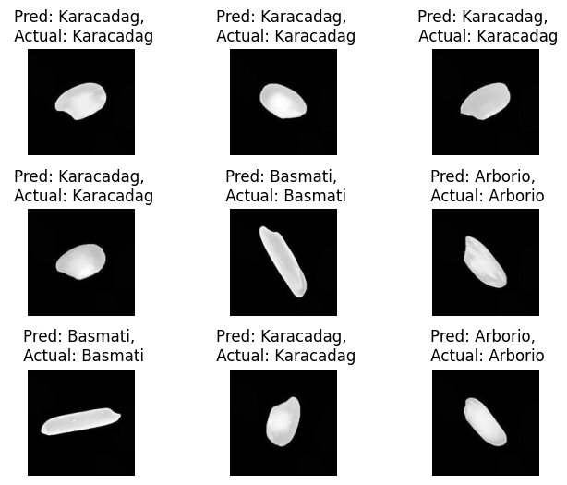
Figure 2. Test images prediction example of testing data.

  - Evaluation of the model
    - Evaluate the loss and accuracy of the model using the testing data.
    - Tune model’s hyperparameters to achieve more than 90% accuracy.
  - Visualizing model performance
    - Visualize the model accuracy and loss performance using matplotlib plotting tool.

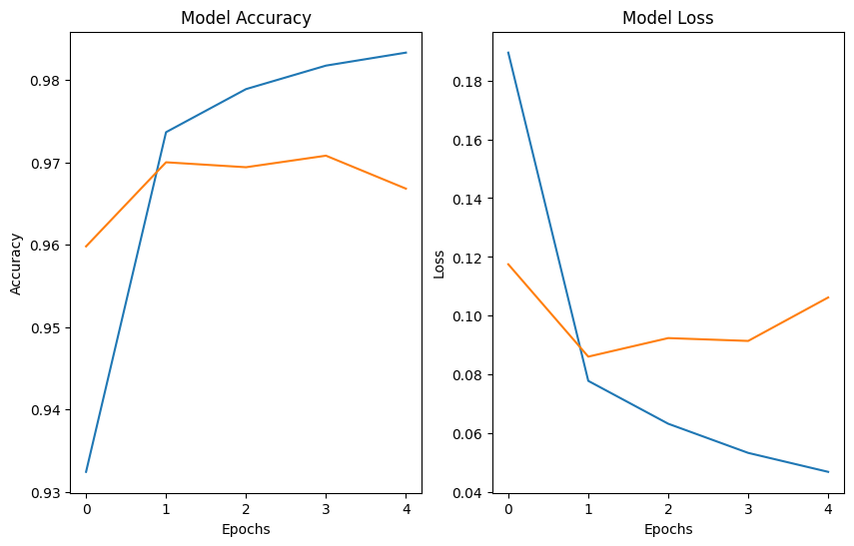
Figure 3. Model Accuracy and Loss Graph

References
- https://www.kaggle.com/datasets/muratkokludataset/rice-image-dataset

